**Diavox SLMS Project Plan**

**Software License Management System**

**DIAVOX SLMS (SOFTWARE LICENSE MANAGEMENT SYSTEM)**

* A Software License Management System (SLMS) is a tool or software application designed to help organizations effectively manage their software licenses. It enables businesses to keep track of their software assets, monitor license compliance, and optimize license usage.

**DEVELOPMENT TOOLS:**

* Oracle Linux 8
* Laravel (latest)
* MySQL 8
* PHP 8.1
* Apache

**The Web Application**

**Login**

* Users can login securely into the system.
* Users password must be at a high level with patterns below:
  + Must have atleast 1 lower case letter.
  + Must have atleast 1 upper case letter.
  + Must have atleast 1 number.
  + Must have atleast 1 special character.
  + Must consist of atleast 8 character length.
* Login must have a “forgot password”.
* Do not include “remember me”.
* No registration view.

**Dashboard**

* Must have some quick links to
  + Create a Ticket
  + File a Report
  + Generate License
* Should be able to see recent clients added to system
* Should be able to see recent license updates
* Should be able to see some recent tickets and reports

**Management**

* Must be able to have CRUD for ff below:
  + Users
  + Clients
  + Softwares
* Users:
  + User management is a component of the system that is responsible for managing user accounts.
  + Users must be able to login using username or email.
  + Users must have roles. A single user can have multiple roles.
* Clients
  + Client management is a component of the system that is designed to effectively manage clients or customers.
  + A client must have a code composed of a 3 character length. (ex. DVX for Diavox)
  + Clients must include information such as company name, description, address, location (for google maps), contacts (persons, email addresses, numbers)
  + A client can have multiple contact persons, emails and numbers.
* Softwares
  + Software management is a component of the system that is focused on managing software assets.
  + A software must have a code composed of a 3 to 5 character length. (ex. CWOW for Cignal WOW, or CWCRE – Cignal WeCare)
  + Software must include information such as software name, description, version.
  + Software should be able to store software requirements such as Operating System, CPU, RAM, Disk Storage, etc.
  + Not all software have licensing capabilities so we must include a boolean column for with_licensing.

**Licenses**

* License module is a component of the system where users can upload the license file and generate a permanent license.
* License accepts a sysconfig.dat file type.
* Generating a license should have a unique Serial Number.
* Serial Number has a pattern of 6 digit (ex. 050201)
* Serial Number can be automatically generated (auto-numbered), and/or manually entered.
* User must select a client/customer first. If the client is a new client, it should be created first.
* User must select a software. Only software with_licensing will be listed in the dropdown.
* Each software has different license attributes which should and must be handled properly by the system.

Example:

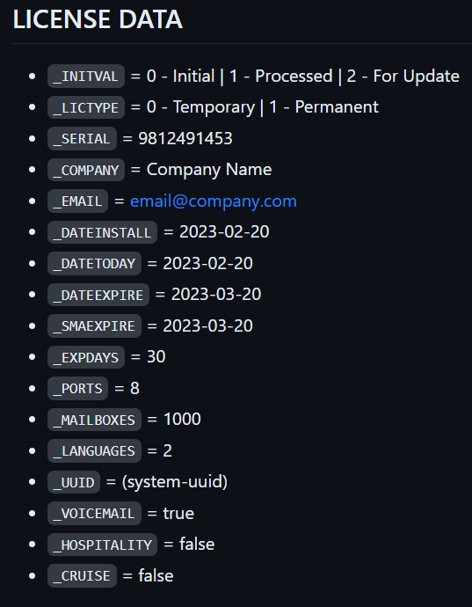

* The encryption uses laravel encryption and decryption package below:
  + **use Illuminate\Encryption\Encrypter;**
* It is also using a cipher of **AES-256-CBC**.
* While the key is hidden statically inside the DiavoxLicenser class.
* DiavoxLicenser is a PHP class protected by source guardian and will be provided with separate documentation. Currently protected in PHP 8.1 version loader.
* <https://www.sourceguardian.com/loaders.html>
* SG loaders are required in order for encrypted PHP to run, otherwise, it will throw an error.

**Ticketing**

* To be updated.